Quiz Radioisotopes
- Identify each of the following statements as being either TRUE (T) or FALSE (F)
___ The radioactive decay of any particular unstable atom is a random process.
___ The average time taken for half of the atoms to decay is called the radioactive half-life.
___ Radioisotopes of different elements have different half-lives.
___ All radioisotopes of the same elements have the same half-life.
___ A beta particle consists of two protons and two neutrons.
___ The mass of the nucleus does not change significantly when beta decay occurs.
___ From 400 g of an isotope with a half-life of 1 hour, 100 g remains after 4 hours.
___ Alpha particles are identical to a helium nucleus
___ Beta particles are radioactive
___ Technetium 99m is one of the most important medical isotopes
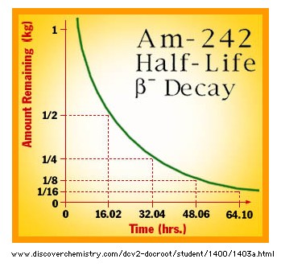
- Deduce the half-life of americium-242 from the graph above

If 500 g was present at a particular time, calculate the mass remaining after six more half-lives.

